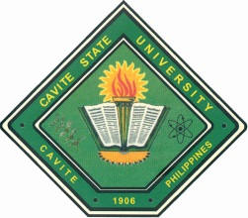
Republic of the Philippines

CAVITE STATE UNIVERSITY
CCAT Campus
Rosario, Cavite
(046) 437-9505 / (046) 437-6659
cvsu.rosario@gmail.com
www.cvsu-rosario.edu.ph

(DEPARTMENT)

Trainee :

Title : A NARRATIVE REPORT: TRAINING EXPERIENCES AT

APPROVED:

_____ REGIE C. DELOS REYES _____
Area Coordinator Date OJT Coordinator Date

_____ MARILOU P. LUSECO _____
Department Chairperson Date Director, Instructions Date

JOSE P. LISAMA, EdD _____
Campus Administrator Date

