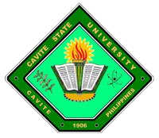
Republic of the Philippines

CAVITE STATE UNIVERSITY
Cavite College of Arts and Trades
CvSU-CCAT Campus
Rosario, Cavite
(046) 437-9505 to 9508
cvsu.rosario@gmail.com

[DEPARTMENT, ALL CAPS, BOLDFACE, 12]

Name : [AUTHOR 1, ALL CAPS, BOLDFACE, 11]
[AUTHOR 2, ALL CAPS, BOLDFACE, 11]
[AUTHOR 3, ALL CAPS, BOLDFACE, 11]

Course/Major : [ALL CAPS, BOLDFACE, 11]

Research Title : [ALL CAPS, BOLDFACE, 11]

A P P R O V E D :

DIANE P. ARAYATA DANIEL A. VILLANUEVA
Adviser Date Technical Critic Date

CHRISTOPHER G. ESTONILO CHRISTOPHER G. ESTONILO
Unit Research Coordinator Date Department Chairman Date

GEE JAY C. BARTOLOME MARILOU P. LUSECO, MAT
Coordinator, Research Services Date Director, RECETS Date

JOSE P. LISAMA, Ed. D.
Campus Administrator Date

