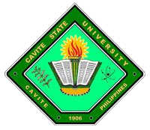
Republic of the Philippines

CAVITE STATE UNIVERSITY
Cavite College of Arts and Trades
CvSU-CCAT Campus
Rosario, Cavite
(046) 437-9505 to 9508
cvsu.rosario@gmail.com

CERTIFICATE OF COMPLETION

November 27, 2015

To whom it may concern:

This is to certify that Mr. Gee Jay C. Bartolome has successfully defended his thesis entitled ‘Development and Evaluation of a Solar Dryer for Tinapa Processing’ on November 30, 2015 at the Audio-visual Room of the Department of Computer Studies.

DIANE P. ARAYATA DANIEL A. VILLANUEVA
Adviser Date Technical Critic Date

JANICE dG. DULCE CHRISTOPHER G. ESTONILO
Panelist Date Panelist Date

CHRISTOPHER G. ESTONILO CHRISTOPHER G. ESTONILO
Unit Research Coordinator Date Department Chairperson Date

GEE JAY C. BARTOLOME MARILOU P. LUSECO, MAT
Coordinator, Research Services Date Director, RECETS Date

JOSE P. LISAMA, Ed. D.
Campus Administrator Date

