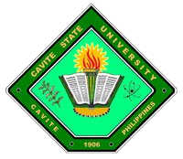
Republic of the Philippines

CAVITE STATE UNIVERSITY
Cavite College of Arts and Trades
CvSU-CCAT Campus
Rosario, Cavite
(046) 437-9505 to 9508
cvsu.rosario@gmail.com

[DEPARTMENT, ALL CAPS, BOLDFACE, 11]

OUTLINE APPROVAL SHEET

Name : [AUTHOR 1, ALL CAPS, BOLDFACE, 11]
[AUTHOR 2, ALL CAPS, BOLDFACE, 11]
[AUTHOR 3, ALL CAPS, BOLDFACE, 11]

Course/Major : [ALL CAPS, BOLDFACE, 11]

Research Title : [ALL CAPS, BOLDFACE, 11]

APPROVED:

DIANE P. ARAYATA DANIEL A. VILLANUEVA
Adviser Date Technical Critic Date

CHRISTOPHER G. ESTONILO CHRISTOPHER G. ESTONILO
Unit Research Coordinator Date Department Chairperson Date

MARILOU P. LUSECO, MAT JOSE P. LISAMA, Ed. D.
RECETS Director Date Campus Administrator Date

